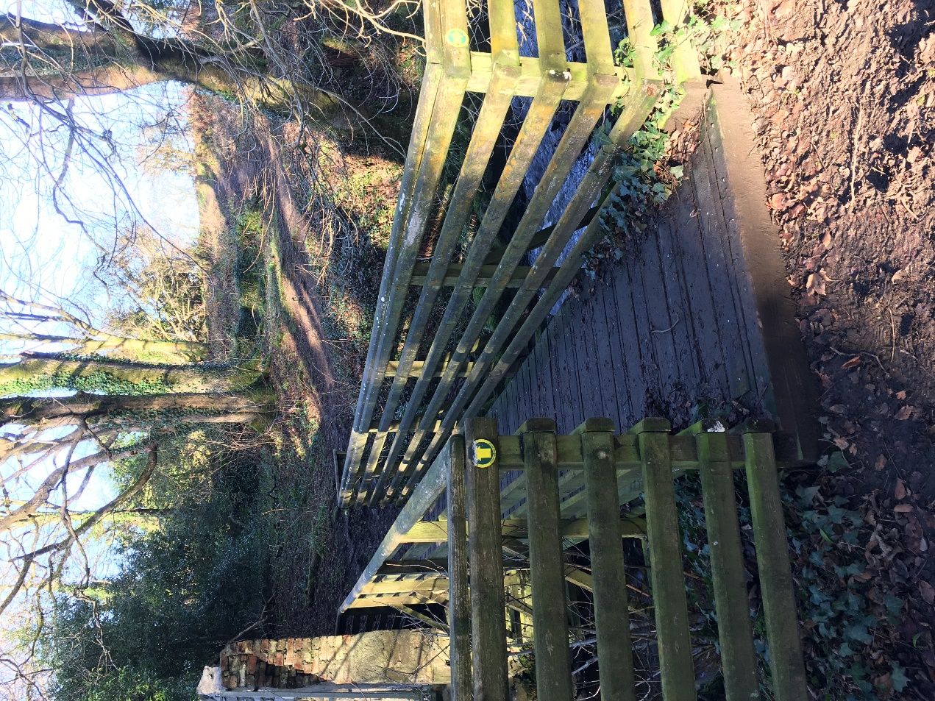

Improving Path Access
Balkail Wood, Glenluce

Invitation to Tender
September 2019

Introduction
Old Luce Development Trust (OLDT) wishes to commission two separate elements of a path improvement project in woods locally known as ‘The Glen’:

- the construction of new path, and
- the manufacture of two galvanised steel bridges.

The two elements form two separate invitations to tender and should be quoted for separately. Applicants may tender for one or both pieces of work.

Old Luce Development Trust
Old Luce Development Trust is a registered charity and a Company Limited by Guarantee incorporated in 2016 to benefit the people residing in the parish of Old Luce, with the following objects:

- The advancement of community development, including the advancement of rural regeneration.
- The provision of recreational facilities, or the organisation of recreational activities with the object of improving the conditions of life for the persons for whom facilities or activities are primarily intended.
- The advancement of citizenship, as a sub-set within the wider charitable purpose of the advancement of community development.
- The advancement of environmental protection or environmental improvement.
- The advancement of the arts, culture, heritage or science.

The Woodland
The Trust has recently taken ownership of Balkail Wood as a gift from the old Wemyss estate lands in the parish. The wood, which totals an estimated 5 acres, is adjacent to the village of Glenluce, with a number of access points, as indicated on the attached plan.

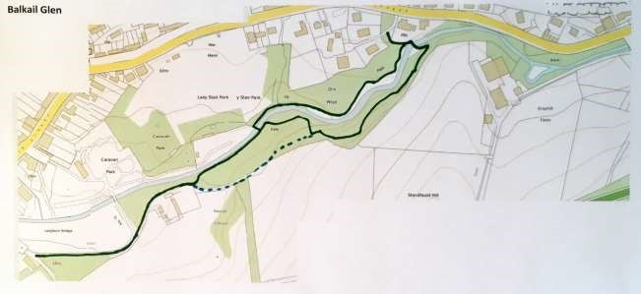

A circular route is currently provided by unsurfaced footpaths on either side of the Lady Burn and two footbridges. Some repairs have been made intermittently but the paths require further work.

The Trust wishes to improve the woodland for increased community use and as a destination for visitors. The Trust has established a volunteer lead group 'Friends of the Glen' and is in the process of developing a Woodland Management Plan.

Tenders
Tenders are now invited for two elements of the path improvement project.

A: Construction of Balkail Glen Footpath
We are currently seeking contractors for the construction of 535m of 1.5m wide new path metres of New Path Unbound Surface (whinstone / granite dust or similar) path:

- If ground is hard and well drained, construct standard 'full tray' path:
  - dig out a rectangular section 'full tray' to at least 100 millimetres depth
  - fill with Type 1 core base material – 100 millimetres depth and compact / roll
  - add surfacing layer of whinstone or granite dust – 25 millimetres depth and compact / roll

- If ground is soft or poorly drained, construct a 'half-tray' with geotextile path:
  - dig out at least 50 millimetres deep, and use arisings to build edging
  - line with geotextile; also with geogrid if ground is very soft or wet
  - fill with Type 1 core base material – 100 millimetres depth and compact / roll
  - add surfacing layer of whinstone or granite dust – 25 millimetres depth and compact / roll

- Soft spots or low spots to be excavated and filled and path compacted to max 1:40 cross fall or min 1:50 camber as required, compacted to refusal using a heavy vibrating roller and path surfacing of 25mm of 6mm to dust whinstone / granite dust compacted as for subbase. Surface regularity max 10mm gap under 3m straight edge for subbase and max 5mm gap for path surface.
You must take and retain for inspection dated photographic evidence of the construction phase, to include the works below ground level, with a scale / ruler included to show depths of tray / base layer / surface layer at least every 100 metres.
B: Manufacture of two Bespoke Galvanised Steel Bridges
We are currently seeking contractors for the manufacture of two bespoke galvanised steel bridges. 8.2m x 1.5m & 5m x 1.5m. Bridges are to be manufactured in accordance with the Paths for All 'Path Bridges’ guide.

You must take and retain for inspection dated photographic evidence of the construction phase, to include the works below ground level.

Other Requirements
All works must comply with the specifications. A complete photographic record of each stage of works must be maintained as evidence to satisfy the conditions of the grant payment. You must maintain a diary of photographic evidence of the construction phase before and after, to include the works below ground level, with an accompanying scale / ruler included to show depths of tray / base layer / surface layer at intervals of at least every 100 metres (photos to be a minimum of 200Kb). Depth of foundations and any below ground works should be photographed with measurements before backfilling. Payment of the grant will only be made on production of satisfactory diary photographs.

If any quantities of these works are to change during the construction phase, the Trust must agree to the change and should be notified as soon as possible, as failure to notify the grant provider of any change by the end of November 2019 may mean loss of grant.

Timescales
Funding for these works has been supplied through a Scottish Government grant via the Agri-Environment Climate Scheme, Improving Public Access program. A requirement of this funding is that all works must be completed by early December.

Due to the short time constraints on the grant, all tenders must be received no later than the prescribed date, with the tendering company committing to all works being completed and fully compliant with grant specifications by 14 December 2019.

Copyright
Copyright of any documentation created as part of this work, including but not limited to drawings and plans is to be vested in OLDT.

Tender
The tender(s) should include:

- Confirmation of proposed methodology
- The cost of conducting the work, inclusive of fees, expenses, charges, meetings and VAT
- Evidence of recent projects worked on which are similar in type and scale to the current proposal
- Names of two contacts from two separate organisations where similar work has been undertaken, one to be within the last 2 years who can be approached for references
- A timetable showing the various milestones including the anticipated dates of completion

Evaluation criteria
It is expected that the selection will be based on 70% quality and 30% cost.

Budget
Please itemise costs for the work to include VAT if applicable and likely travel/incidental expenses incurred in carrying out the work. The budget for these tasks is limited by a grant provided externally and tenders should quote for all work to complete the project, whether carried out by the applicant or a third party. It will not be possible to retrospectively apply for additional funds for this project, therefore, only fixed quotes will be accepted. Please do not submit estimates, as these can not be accepted.

Closing date
Friday September 21st

OLDT contact
All queries and proposals should be sent to the contact details below.

Michael Lane
Chairman

Tracey Murray
Development Officer

Kevin Cheeseman
Administrator

Address:
Old Luce Development Trust
Public Hall, 22 Main Street, Glenluce, Newton Stewart DG8 0PR

Email: tracey@oldluce.org.uk

Path map: Balkail Glen

Outline Map: Balkail Glen

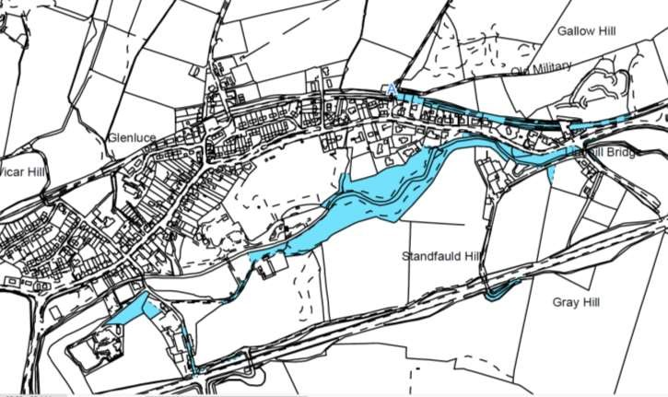

Access to Balkail Glen

Balkail Glen is accessed from four main points :
1: Along the laneway access Bankfield Road 2: Access from Skate Park
3: Second access point from Lady Stair Park
4: Access of Main Street (Manswood)

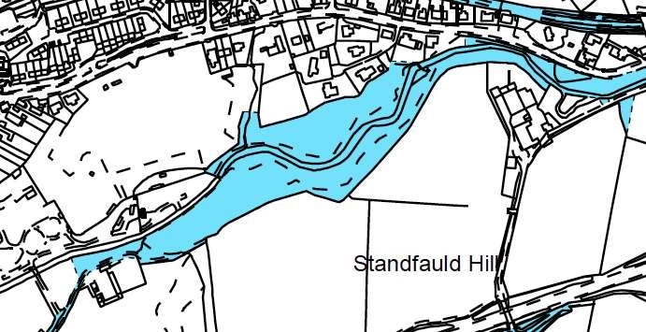
Lady Stair Park

(
Football Pitch
,
Skate Park
,

Children’s Playground
)

2

3

4

1

